Web Technology - College Course Portal Website
Ganga Gowri P
241801070

ASSIGNMENT - 2

PROGRAM – 1
CODE :
<!DOCTYPE html>
<html>
<head>
<title>Rajalakshmi Engineering College - Course Portal</title>
<link rel="stylesheet" href="style.css">
<style>
h2 {
color: darkred;
}
table {
background-color: lightgray;
}</style>
</head>
<body>
<h1 style="color:blue; text-align:center;">
Rajalakshmi Engineering College
</h1>
<h2>College Course Portal</h2>
<h3>Admission Process</h3>
<ol>
<li>Online Registration</li>
<li>Fill Application Form</li>
<li>Upload Required Documents</li>
<li>Pay Application Fee</li>
<li>Admission Confirmation</li>
</ol>

<h3>Departments Offered</h3>
<ul>
<li>Artificial Intelligence and Data Science</li>
<li>Computer Science and Engineering</li>
<li>Information Technology</li>
<li>Electronics and Communication Engineering</li>
<li>Mechanical Engineering</li>
</ul>

<h3>Course Details</h3>
<table border="1" cellpadding="8">
<tr>
<th>Course Code</th>
<th>Course Name</th>
<th>Credits</th>
<th>Faculty</th>
</tr>
<tr>
<td>CS201</td>
<td>Data Structures</td>
<td>4</td>
<td>Dr. Kumar</td>
</tr>
<tr>
<td>CS305</td>
<td>Web Technology</td>
<td>3</td>
<td>Prof. Meena</td>
</tr>
<tr>
<td>AI401</td>
<td>Machine Learning</td>
<td>4</td>
<td>Dr. Arun</td>
</tr>
<tr>
<td>DB210</td>
<td>Database Management Systems</td>
<td>3</td>
<td>Prof. Divya</td>
</tr>
</table>

</body>
</html>

OUTPUT :
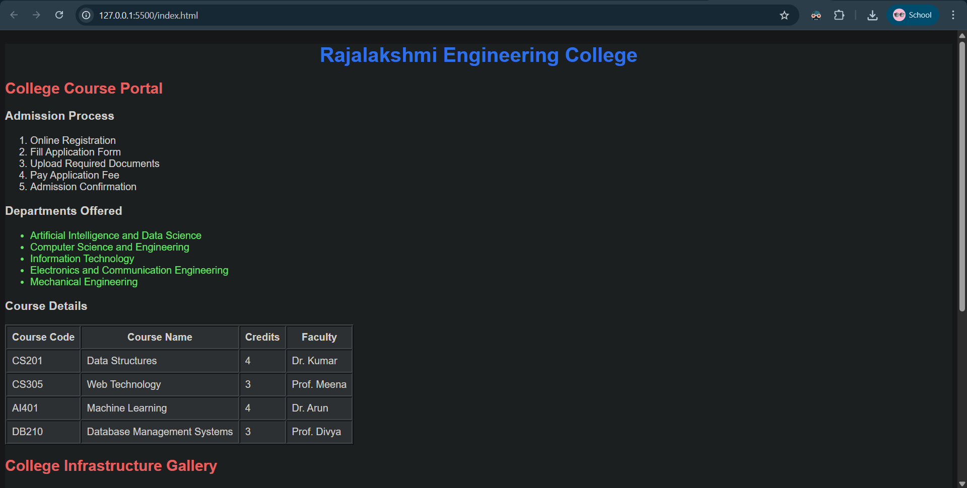

GIT-HUB LINK :
https://github.com/Ganga-Gowri/course-portal-html/blob/e8198bbb94661b41b9a1eff795967c500a9e0e33/index.html
PROGRAM - 2
CODE :
HOME.HTML

<!DOCTYPE html>
<html>
<head>
<title>Rajalakshmi Engineering College - Course Portal</title>
</head>

<frameset rows="20%,80%">
<!-- Header Frame -->
<frame src="header.html" name="headerFrame">

<!-- Bottom Split -->
<frameset cols="25%,75%">
<frame src="navigation.html" name="navFrame">
<frame src="content.html" name="contentFrame">
</frameset>
</frameset>
</html>
STYLE.CSS
body {
background: linear-gradient(135deg, #0f172a, #1e293b);
color: #f1f5f9; display: flex;
justify-content: center;
align-items: center;
min-height: 100vh;
}
.portal-card {
width: 800px;
padding: 20px;
border-radius: 15px;
background: #1e293b;
color: #f8fafc; box-shadow: 0px 10px 25px rgba(0,0,0,0.2);
animation: slideIn 2s ease;

h1 {
text-align: center;
animation: glowText 2s infinite alternate;
}
table {
width: 100%;
border-collapse: collapse;
}
th, td {
border: 1px solid black;
padding: 8px;
text-align: center;
}
h1, h2, h3 {
text-align: center;
}
p {
text-align: justify;
}
ul, ol {
text-align: left;
}
img {
display: block;
margin: 20px auto;
border-radius: 10px;
box-shadow: 0px 8px 20px rgba(0,0,0,0.3);
max-width: 100%;
height: auto;

iframe {
display: block;
margin: 20px auto;
border-radius: 10px;
border: 2px solid #333;
}
@keyframes slideIn {
from {
transform: translateY(-100px);
opacity: 0;
}
to {
transform: translateY(0);
opacity: 1;
}
}
@keyframes glowText {
from {
color: #1d4ed8;
}
to {
color: #ef4444;
}
}
OUTPUT :
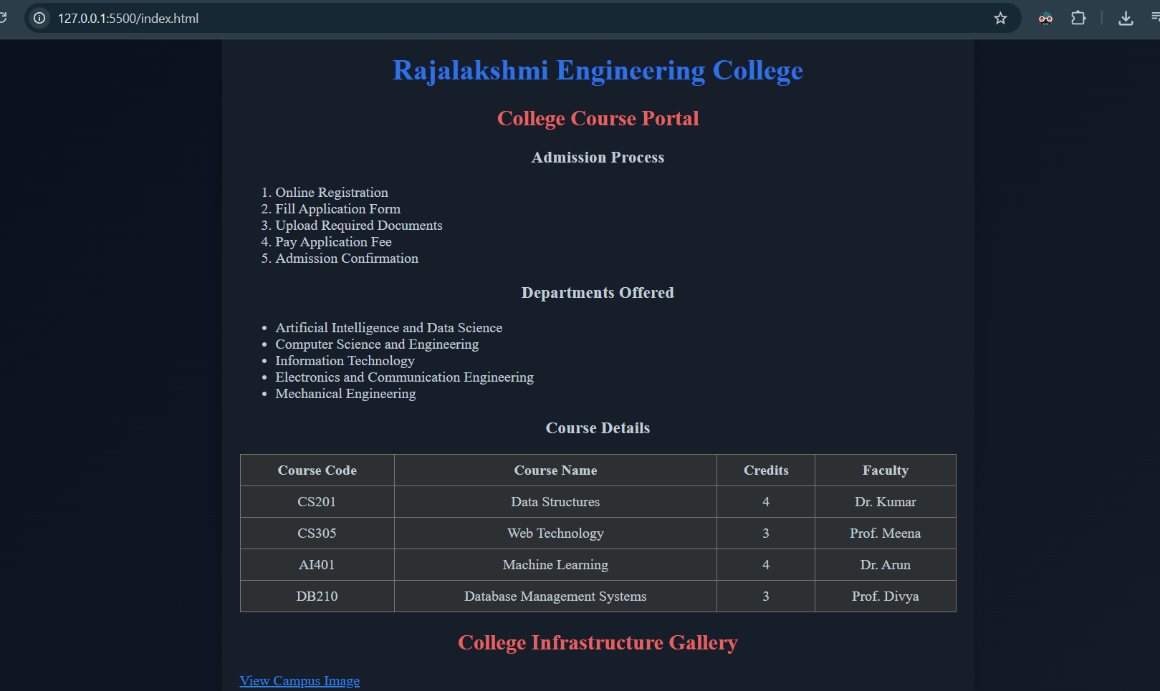

GIT HUB LINK :
https://github.com/Ganga-Gowri/course-portal-html/tree/8e1bbab4751841af707cd27a436efc7a8d271179

